5/4/2026

Project Presentation 3
Agile Team Charter
Team Members | Student Number
Oluhle Makhaye | 222419636
Lukhanyo Mweli | 222830646
Mihlali Mdlangazi | 222035749
Entle Myezo | 230076238

Table of Contents
1. Team Purpose & Vision 2
1.1. Team Mission 2
1.2. Vision Statement 2
1.3. Success Definition 2
1.4. Product/Service 2
2. Team Members & Roles 2
3. Ways of working 3
3.1. Agile Framework 3
3.2. Ceremonies 3
4. Working Agreements 3
5. Communication Plan 3
5.1. Primary Communication Channels 3
5.2. Response-time Expectations 3
5.3. Remote/Hybrid Norms 4
6. Decision Making 4
7. Definition of Done(DoD) 4
8. Core Values & Behaviours 4
8.1. Agile Principles we uphold 4
9. Goals & Milestones 5
9.1. SMART Goals 5
9.2. Project Milestones 5
10. Risk & Constraints 6
10.1. Known Constraints 6
11. Review & Improvement 6
12. Team Commitment 7

Team Purpose & Vision

Team Mission
WASHTRACK exists to solve a recurring and measurable problem faced by students at New Market Junction, Woodstock, Cape Town: the loss of prepaid laundry points due to broken or occupied washing machines. Our team is building a digital platform that gives students real-time visibility into machine status, enables bookings, and allows fault reporting - eliminating wasted points and reducing daily frustration.

Vision Statement
To become the leading laundry management platform across South African student housing, empowering residents with transparency and control over essential shared resources.

Success Definition
- Reduce lost laundry points by at least 80% within the first 3 months of deployment.
- Reduce time spent searching for available machines by 50% or more.
- Achieve measurable improvement in student satisfaction scores.
- Successfully deliver a working MVP within the project timeline.

Product/Service
WASHTRACK is a mobile-enabled web application providing real-time machine status (working, occupied, broken), a booking system for machine reservations, fault reporting with timestamps, laundry point balance tracking, and push notifications for bookings and cycle completion.

Team Members & Roles

Name | Role | Responsibility
Oluhle Makhaye (222419636) | Team Leader / Product Owner | Defines product vision, prioritises backlog, liaises with stakeholders, ensures delivery aligns with business case
Entle Myezo (230076238) | Researcher / Agile Lead | Facilitates Agile ceremonies, conducts user research and validation, tracks sprint progress and impediments
Mihlali Mdlangazi (222035749) | Writer / Editor / Analyst | Documents requirements, produces written deliverables, performs analysis and testing
Lukhanyo Mweli (222830646) | Presenter / Developer | Leads presentations and demos, contributes to development and implementation of core features
All Members | Designer | UI/UX design responsibilities are shared across the team collaboratively

Ways of working

Agile Framework
The team will operate using a Kanban-based Agile framework, suitable for the phased delivery structure of the WASHTRACK project (MVP → Integration → Expansion). Work will be tracked on a shared Kanban board, with tasks moving through columns: To Do → In Progress → Review → Done.

Ceremonies
Ceremony | Frequency | Purpose
Daily Stand-up | Daily | Share progress, surface blockers, align on day's priorities
Sprint Planning | Bi-Weekly | Select and assign tasks for the upcoming sprint; clarify scope
Review / Demo | End of each sprint | Show working features to the team; get feedback before moving to the next phase
Retrospective | End of each sprint | Honest reflection on what worked and what didn't; agree on one or two concrete improvements

Working Agreements
- We start meetings on time. If you're going to be late, message the group chat beforehand.
- Everyone is expected to have their tasks done before stand-up, not during.
- No one merges changes to the main branch without at least one other person reviewing it first.
- If you're stuck for more than an hour, ask for help — don't sit on a blocker and miss a deadline.
- We don't throw work over the fence. If you hand something off, make sure the next person understands it.
- Phones away during meetings unless we're using them for the work.

Communication Plan

Primary Communication Channels
- WhatsApp Group: day-to-day communication, quick updates, and urgent messages.

Response-time Expectations
- Core hours: Monday to Friday, 08:00 – 19:00.
- Urgent messages: respond within 2 hours during core hours.
- Non-urgent messages: respond within 24 hours.
- Assignment-related messages on weekends: respond by Sunday evening.

Remote/Hybrid Norms
- Online meetings: use a shared platform like Microsoft Teams.
- All decisions made in meetings must be summarised in the group chat.

Decision Making
Most day-to-day decisions are made by whoever owns that task, we don't need a meeting for everything. For decisions that affect the whole team or the product direction, we discuss as a group and aim for consensus. If we can't agree after a reasonable discussion, the Team Leader makes the final call. Any decision made outside of a meeting gets posted in the WhatsApp group, so everyone stays in the loop.

Definition of Done (DoD)
A task is only done when:
- The work matches what was described in the backlog item
- It's been reviewed by at least one other team member
- Any related documentation or written deliverable has been updated
- It's been moved to "Done" on the Kanban board
- The team has been informed (either in stand-up or the group chat)
Nothing gets marked as done just because the work feels finished, it has to meet all of the above.

Core Values & Behaviours
Value | What it Means for WASHTRACK
Respect | We value every team member's contribution, time, and perspective.
Transparency | We are open about progress, challenges, and mistakes — no surprises.
Accountability | We own our tasks and follow through on commitments.
Trust | We trust each other to deliver and act in the team's best interest.
Learning Mindset | We treat every challenge as an opportunity to grow, individually and as a team.

Agile Principles we uphold
- Deliver working software / deliverables frequently.
- Welcome changing requirements, even late in the project.
- Reflect regularly and adjust our ways of working accordingly.

Goals & Milestones

SMART Goals
- Deliver a fully functional WASHTRACK MVP (web app) within the first 6 months of the project, achieving at least 80% reduction in reported laundry point losses.
- Complete user testing with a minimum of 5 residents and incorporate feedback into the product within 2 weeks of testing.
- Present a working demo to stakeholders by the end of Phase 3.
- Achieve a 50% or more reduction in time students spend searching for available machines, measured through follow-up surveys.

Project Milestones
Phase | Timeline | Key Milestone
Phase 1 | Month 0-1 | Requirements gathered, problem validated, Kanban board set up, team charter finalised
Phase 2 | Months 2-6 | MVP built and internally tested machine status, booking system, and fault reporting functional
Phase 3 | Months 7-12 | User testing completed, feedback incorporated, working demo presented to stakeholders

Risk & Constraints
Risk | Impact | Mitigation Strategy
Low student adoption of the platform | Medium | Design simple, intuitive UX
South Point rejects integration request | High | Launch standalone MVP first; demonstrate value before approaching management
Incorrect machine status data | Medium | Combine user-submitted reports with verification mechanism
Students unwilling to pay for the service | High | Change the plan so that South Point pays for the service as part of what they offer to their tenants
Time constraints due to academic workload | Medium | Use Kanban to manage capacity; raise blockers early in stand-ups

Known Constraints
- Budget: Student-built MVP - no external development budget; reliance on free/open-source tools.
- Tools: IntelliJ, GitHub, Trello
- Time: Academic deadlines constrain sprint velocity; milestones aligned with course calendar.
Dependencies: Full integration with South Point systems requires external approval.

Review & Improvement
At the end of each sprint, we hold a short retrospective. We keep it simple — what went well, what didn't, and one or two things we're going to change (not just talk about). Action items from retros get added to the next sprint so they don't get forgotten. If something is going wrong mid-sprint, we don't wait — we raise it in stand-up and adjust.

Team Commitment
By contributing to this project, all team members agree to uphold the principles, values, and working agreements outlined in this charter.
Name | Student Number | Signature/Agreement
Oluhle Makhaye | 222419636 | 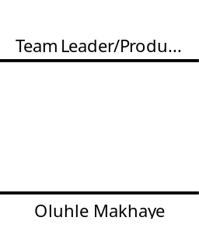
Entle Myezo | 230076238 | 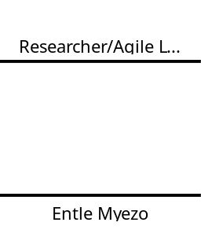
Mihlali Mdlangazi | 222035749 | 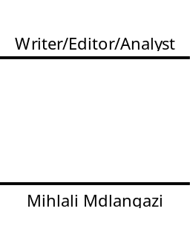
Lukhanyo Mweli | 222830646 | 